FOUNDATIONAL ASSIGNMENT FOR BOOTCAMP TRAINING

NAME-Aakangsha Chowdhury

Question 1: Make a calculator using Javascript, css and html.

Answer:

<title>Simple Calculator</title>

<style>

h1

{

text-align:centre;

padding:23px;

background-color:blueviolet;

color:whitesmoke;

}

.use{

width:41px;

background-color:lavender;

}

.formstyle

{

width:300px;

height:530px;

margin:auto;

border:3px purple;

border radius:5px;

padding:20px;

}

</style>

</head>

<body>

<h1>calculator</h1>

<div class="formstyle">

<form name="calculator">

<input type="text"name="answer"id="display">

<br>

<input type="button"class="use" value="7"onclick="calculator.answer.value+='7'">

<input type="button"class="use" value="8"onclick="calculator.answer.value+='8'">

<input type="button"class="use" value="9"onclick="calculator.answer.value+='9'">

<input type="button"class="use" value="*"onclick="calculator.answer.value+='*'">

<br><br>

<input type="button"class="use" value="4"onclick="calculator.answer.value+='4'">

<input type="button"class="use" value="5"onclick="calculator.answer.value+='5'">

<input type="button"class="use" value="6"onclick="calculator.answer.value+='6'">

<input type="button"class="use" value="-"onclick="calculator.answer.value+='-'">

<br><br>

<input type="button"class="use" value="1"onclick="calculator.answer.value+='1'">

<input type="button"class="use" value="2"onclick="calculator.answer.value+='2'">

<input type="button"class="use" value="3"onclick="calculator.answer.value+='3'">

<input type="button"class="use" value="+"onclick="calculator.answer.value+='+'">

<br><br>

<input type="button"class="use" value="/"onclick="calculator.answer.value+='/'">

<input type="button"class="use" value="0"onclick="calculator.answer.value+='0'">

<input type="button"class="use" value="."onclick="calculator.answer.value+='.'">

<input type="button"class="use" value="="onclick="calculator.answer.value=eval(answer.value)"class="equal">

<br><br>

<input type="button"class="use"value="back"onclick="calculator.answer.value=answer.value.slice(0,-1)">

<input type="button"class="use"value="clear all"onclick="calculator.answer.value=''"id="clear">

<br>

</form>

</div>

</body>

</html>

</DOCTYPE>

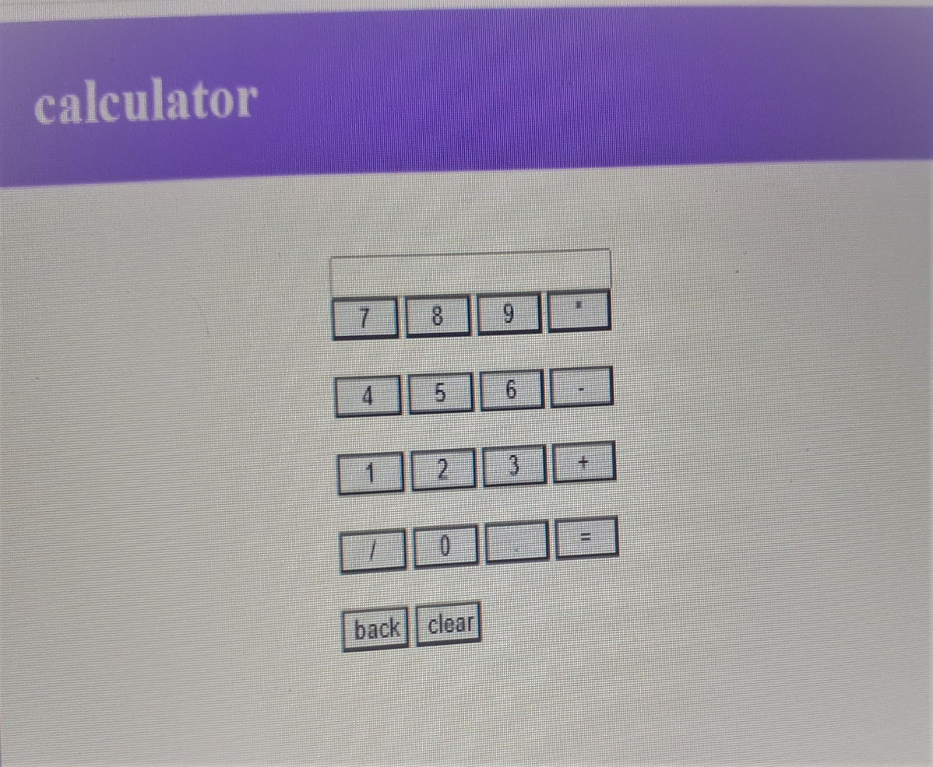

Question 2:CLASS DIAGRAM TO SHOW E COMMERCE TO BE REPRESENTED IN C# OR JAVA CODE FORM WITHOUT MAIN FUNCTION.

import java.util.*;

class User {

    private boolean role;

    private String ID;

    private String password;

    public User(){

    }

    public User( boolean role, String lid, String pass){

        this.role = role;

        ID = lid;

        password = pass;

    }

    private boolean verifyUser(){

        if(loginID != null && password != null && role){

            return true;

        }

        return false;

    }

}

class Customer extends User{

    public String id, address, phone, email;

    public Customer(String i, String ad, String ph, String em){

[this.id](http://this.id/) = i;

        this.address = ad;

        this.phone = ph;

        this.email = em;

    }

    public Customer(String phone){

        this.phone = phone;

    }

    public String login(String mail, String num){

//code

  }

    public String register(String addr, String mail, String num){

//code

        }

    public void updateProfile(String addr, String mail, String num){

        address = addr;

        email = mail;

        phone = num;

    }

}

class shoppingCart{

    private Date created;

    private Customer c;

    public shoppingCart(Date d){

        created = d;

    }

    public shoppingCart(){

        //code

    }

    public void checkOut(){

        System.out.println("Order summary : ");

    }

    public void viewCartDetails(){

        System.out.println("Showing cart details : ");

    }

    public void updateQuantity(){

        System.out.println("Quantity updated successfully...");

    }

}

class Reviews {

    private String reviewId;

    private String customerId;

    private String reviewContent;

    private Int rating;

    private String parentId;

    private String productId;

    private Customer customer;

    public Reviews(String rid, String cid, String rc, Integer r, String pid, String prodId  ){

        reviewId = rid;

        customerId = cid;

        reviewContent = rc;

        rating = r;

        parentId = pid;

        productId = prodId;

    }

    public void addReview(){

        //code to be written

    }

    public void deleteReview(){

        //code todo

    }

    public void editReview(){

        //code

    }

}

class Orders{

    private String id;

    private String sellId;

    private String cusId;

    private String proId;

    private String tAmt;

    private Date oDate;

    private String address;

    private Date deliDate;

    private String deliStatus;

    private Customer c;

    public Orders(String id, String sellId, String cusId, String proId, String tAmt, Date oDate, String address, Date deliDate, String deliStatus){

[this.id](http://this.id/) = id;

        this.sellId = sellId;

        this.cusId = cusId;

        this.proId = proId;

        this.tAmt = tAmt;

        this.oDate = oDate;

        this.address = address;

        this.deliDate = deliDate;

        this.deliStatus = deliStatus;

    }

    public void placeOrder(){

//code todo

    }

}

class Product{

    private String prodId;

    private String prodName;

    private Integer prodCost;

    private String sellerID;

    private Date postedDate;

    private shoppingCart scart;

    public Product(String pid, String pname, Integer pcost, String sid, Date pd, shoppingCart scart){

        prodId = pid;

        prodName = pname;

        prodCost = pcost;

        sellerID = sid;

        postedDate = pd;

        this.scart = scart;

    }

    public void addToCart(){

//code

    }

    public void sellProduct(){

        //code

    }

    private void getProductDetails(t){

        //code todo

    }

    private void buyProduct(){

//code

    }

}

class Seller extends User{

    private String id, address, phone, email;

    private int sellerRating;

    public Seller(String i, String ad, String ph, String em, int sr){

[this.id](http://this.id/) = i;

        this.address = ad;

        this.phone = ph;

        this.email = em;

        sellerRating = sr;

    }

    public String login(String mail, String num){

//code

}

    public String register(){

    //code   }

    public void updateProfile(){

        //code

    }

}

class Payment{

    private String id;

    private String orderID;

    private boolean paid;

    private int total;

    private String details;

    private Orders o;

    private Customer c;

    private void sendOTP(){

        //code

    }

    private String confirmTransaction(){

        //code

    }

    private void getPaymentDetails(){

        //code

    }

    private void makeTransaction(){

//code    }

}

}